**Here's the analysis plan for "Analyzing Smart Device Usage Trends for Bellabeat" organized into the "ask, prepare, process, analyze, share, and act" framework:**

**1. Ask**

* **Business Objective: Understand how consumers utilize non-Bellabeat smart devices to enhance Bellabeat's marketing strategy for a specific product.**
* **Key Questions:** 
  + **What are the current trends in smart device usage (ownership, usage patterns, integration into daily life)?**
  + **How do these trends relate to the typical Bellabeat customer profile?**
  + **How can these insights be leveraged to improve Bellabeat's marketing approach (target audience, messaging, channels, campaigns)?**

**2. Prepare**

* **Data Sources:** 
  + **Kaggle Data Set**
* **Data Collection: Extract relevant data (device ownership rates, usage frequency, app usage patterns, consumer preferences) from identified sources.**

**3. Process**

* **Data Cleaning:** 
  + **Handle missing values.**
  + **Remove duplicates.**
  + **Standardize data formats.**
* **Data Transformation:** 
  + **Aggregate data.**
  + **Calculate percentages.**
  + **Create new variables as needed.**

**4. Analyze**

* **Trend Identification:** 
  + **Analyze data to identify key trends:** 
    - **Increasing device ownership across categories (smartphones, wearables, smart home devices).**
    - **Evolving usage patterns (app usage, social media engagement, content consumption).**
    - **Integration of smart devices into daily life (health & fitness, entertainment, work).**
* **Application to Bellabeat Customers:** 
  + **Consider the typical Bellabeat customer profile (health-conscious women, wellness-focused individuals).**
  + **Determine which identified trends are most relevant to this segment.**
  + **Analyze how these trends can enhance the user experience with Bellabeat products.**
* **Marketing Strategy Implications:** 
  + **Develop recommendations for improving Bellabeat's marketing strategy:** 
    - **Adjustments to target audience.**
    - **Refinement of marketing messages.**
    - **Optimization of marketing channels.**
    - **Development of new campaign ideas.**

**5. Share**

* **Visualizations:**

**Using Tableau we found the below trends   
  
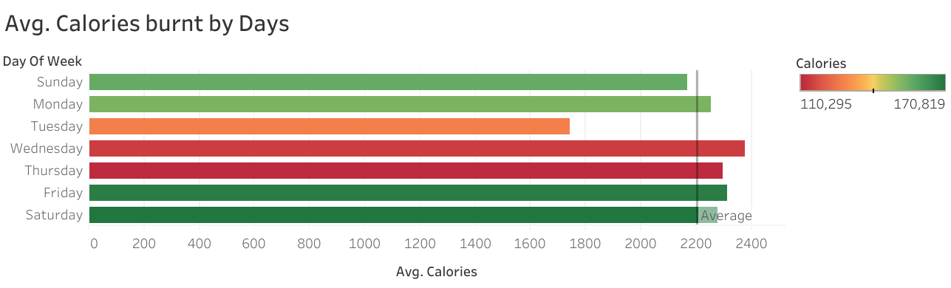**

**Average Calories burnt on Each day of the week**

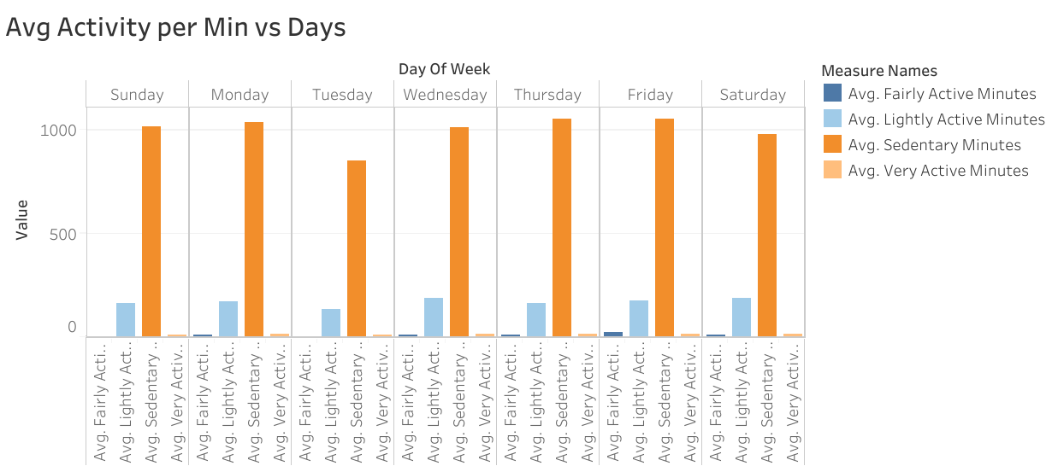

**Average Activity per Min Vs Days**

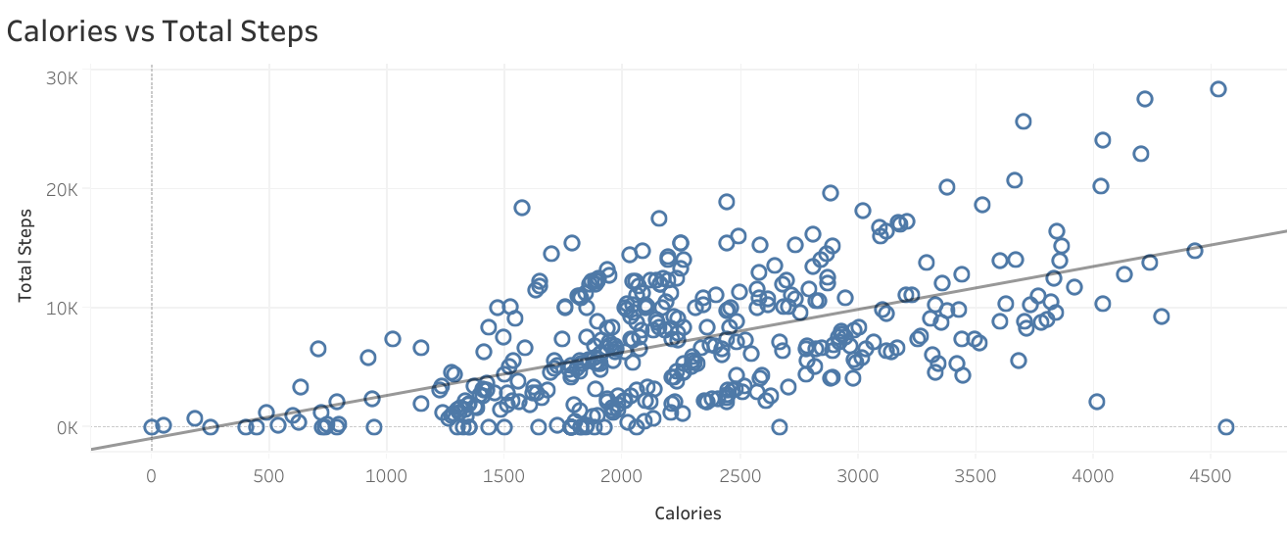

**Calories vs Total Steps**

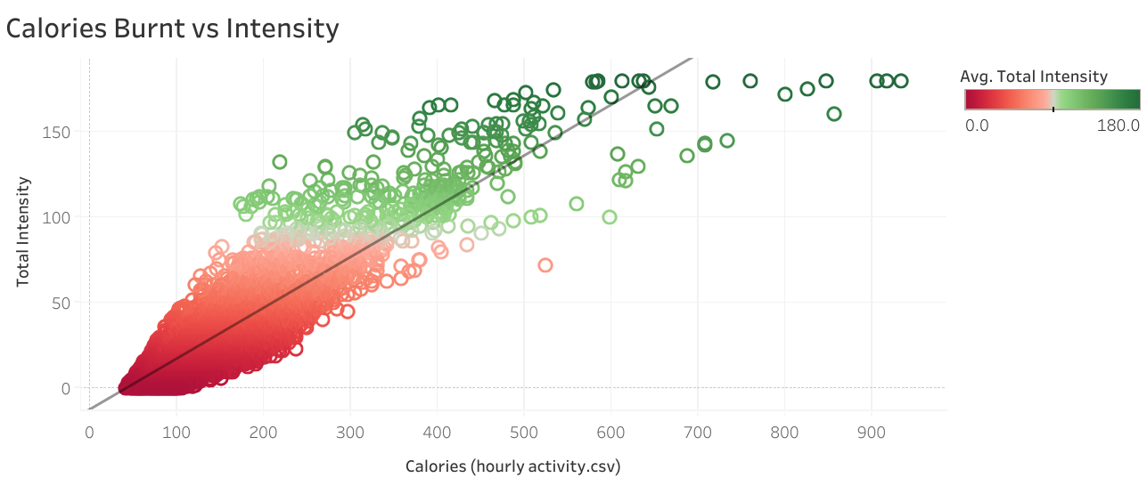

**Calories burnt vs Intensity**

* **Key Findings:** 
  + **We could see that Bellabeat’s consumers are least active on Tuesdays**
  + **Trend of Calories burnt increases with the intensity of the Activity**
  + **Average Calories burnt per week is 2204.2**
* [**Tableau Dashboards**](o%09https:/public.tableau.com/views/BellabeatHowCanaWellnessTechnologyCompanyPlayItSmart_17370184000060/Dashboard1?:language=en-US&:sid=&:redirect=auth&:display_count=n&:origin=viz_share_link)

**6. Act**

* **Content Recommendations:** 
  + **Recommendation 1: Personalized support for fitness goals (automated reminders, personalized guidance).**
  + **Recommendation 2: Integrate data from other fitness trackers (e.g., Mi Band) to enhance user experience and refine marketing.**
  + **Recommendation 3: Highlight seamless integration of Bellabeat devices into corporate environments to improve employee well-being and productivity.**